Master's project for the MSc in Statistical Machine Learning and signal processing

## Specializations in Smart Sensor Systems

**Title of project**: Digital Worker – Automatic detection of occupational physical activity

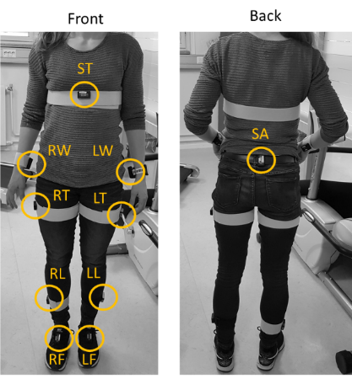**Background and research question**: It is found that strenuous occupational physical activity can lead to workers being granted a disability pension[1] as well as finding their work physically demanding, stressful[2, 3] and exhausting[4]. Musculoskeletal pain is a major health problem in a range of workers [5, 6] and musculoskeletal pain is well-known to be of great consequence for life quality, work participation and productivity. The current digitalization trends in wearable technologies are expected to enable enormous possibilities for novel, flexible, cost-effective and interactive occupational physical activity monitoring and interventions while maintaining and improving work efficiency and health.

**The availability of wearable sensor devices is rapidly increasing and can be used to quantify aspects of human activities [7-10]**. However, these sensors are targeted towards exercise and sport applications and not for occupational settings.

There is therefore a need for the development of accurate and precise methods for monitoring physical and physiological strain by **automatically** **detecting occupational activities from signals** provided by wearable, non-invasive sensors [7-10]. New knowledge on **activity identification from wearable sensors** can be used as a preventive measure and decision support on both an individual level and group level.

**The aim of the project** is to gain knowledge on 1) Inertial measurement units (IMU) time series quality control and pre-processing 2) developing and implementing activity detection algorithms from movement and physiological signals to analyse and manage occupational health and safety within different working environments. This is a joint project of SINTEF and NTNU.

**Assignment**: to develop and test a Python tool for the automatic detection of relevant work-related activities from wearable accelerometer data. The tool can be model-based similarly to existing validated tools such as Acti4, or machine learning-based using data collected for DigitalWorker.

**Proposed plan**:

* Introduction to sensor technology and data from DigitalWorker
* Familiarization with Acti4 and relevant occupational activities
* Development of Python activity detection software
* Implementation and testing of activity detection software on existing data

**Main supervisor**: Victor Gonzalez (SINTEF)  
**Co-supervisor**: Trine Seeberg (SINTEF)

**Contact email**: victor.gonzalez@sintef.no

**References**

1. Stapelfeldt, C.M., et al., *Sick leave patterns as predictors of disability pension or long-term sick leave: a 6.75-year follow-up study in municipal eldercare workers*. 2014, British Medical Journal Publishing Group.

2. Delp, L., et al., *Job Stress and Job Satisfaction: Home Care Workers in a Consumer‐Directed Model of Care.* Health Services Research, 2010. **45**(4): p. 922-940.

3. Denton, M., et al., *Job Stress and Job Dissatisfaction of Home Care Workers in the Context of Health Care Restructuring.* International Journal of Health Services, 2002. **32**(2): p. 327-357.

4. Rønning, E., *"Helsearbeidere" - tøffe kvinner i deltidsjobber ; kvinner i helse- og sosialyrker.* Samfunnsspeilet, 2010. **24**(1): p. 35-42.

5. Lundberg, G. and B. Gerdle, *Musculoskeletal signs in female homecare personnel: A longitudinal epidemiological study.* Work, 2017. **58**(2): p. 135-147.

6. Statistics Norway. *Arbeidsmiljø, levekårsundersøkelsen [Norwegian]*. 2016; Available from: <https://www.ssb.no/statbank/table/10479/tableViewLayout1/>.

7. Palm, P., Gupta, N., Forsman, M., Skotte, J., Nordquist, T., & Holtermann, A. (2018). Exposure to upper arm elevation during work compared to leisure among 12 different occupations measured with triaxial accelerometers. *Annals of work exposures and health*, *62*(6), 689-698.

8. Hendriksen, P. F., Korshøj, M., Skotte, J., & Holtermann, A. (2020). Detection of kneeling and squatting during work using wireless triaxial accelerometers. *Ergonomics*, *63*(5), 607-617.

9. Clays, E., Hallman, D., Oakman, J., & Holtermann, A. (2020). Objectively measured occupational physical activity in blue-collar workers: what is the role of job type, gender and psychosocial resources?. *Applied ergonomics*, *82*, 102948.

10. Hou, C. (2020, May). A study on IMU-based human activity recognition using deep learning and traditional machine learning. In *2020 5th International Conference on Computer and Communication Systems (ICCCS)* (pp. 225-234). IEEE.